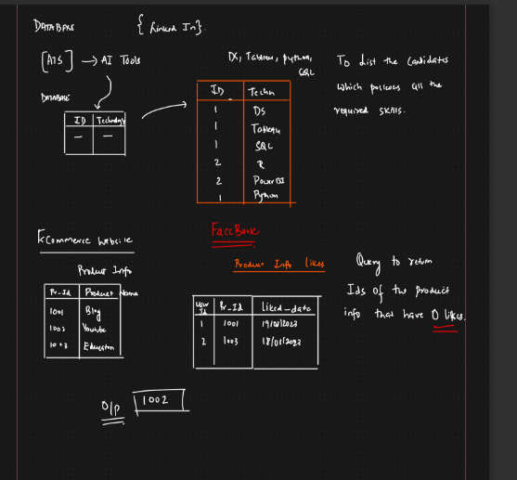

ANSWER:

To retrieve the IDs of the products with 0 likes, assuming you have a table named ProductInfo with columns Pr-Id, ProductName, UserFr-Id, and liked-date, you can use the following SQL query:

SELECT `Pr-Id`, `ProductName`, `UserFr-Id`, `liked-date`

FROM ProductInfo

WHERE `Pr-Id` NOT IN (

SELECT `Pr-Id`

FROM ProductInfo

WHERE `UserFr-Id` = 'liked'

)

This query selects all columns for products where the Pr-Id is not present in the subquery's result set. The subquery retrieves all Pr-Id values where the UserFr-Id is 'liked'. This effectively filters out products that have likes.

Assuming 'liked' is the value present in the UserFr-Id column when a product is liked. Adjust the value accordingly if it differs.